Report

Laboratory Work 10

Dmitry Ladutsko

July 28, 2022

# 1. Prerequisites

## 1.1. Passwords Index

|  |  |  |
| --- | --- | --- |
| Password Group | Login Name | Password |
| Operation System | root | “rootadmin” |
|  | oracle | “oracleadmin” |
|  |  |  |
| Oracle System | sys | “sysadmin” |
|  | system | “sysadmin” |
|  |  |  |
| Oracle Users | All DB users | “%PWD%” |
|  |  |  |
|  |  |  |

## 1.2. Folder Paths Index

|  |  |  |
| --- | --- | --- |
| Path Group | Path Description | Path |
| Operation System | Oracle RDBMS – BIN | /oracle/app/oracle |
|  | Oracle Inventory | /oracle/app/oraInventory |
|  | Oracle Database Storage | /oracle/oradata |
|  | Oracle Install Directory | /oracle/install |
| Oracle | ORACLE_BASE | /oracle/app/oracle |
|  | ORACLE_HOME | $ORACLE_BASE/product/11.2 |
|  |  |  |
| FTP | ftp Incoming Folder | /ftp/incoming |
|  |  |  |
|  |  |  |

# 2. Oracle Architecture - Parallel execution

## 2.1. Task 01: CREATE Example of Select Parallel execution

**The Main Task** is to creating example of Select Parallel execution.

**Task Results:**

Create document that will store all screenshot about Select Parallel execution

* Scipts
* Execution Plan
* Summarize table – Compare time of the same operations

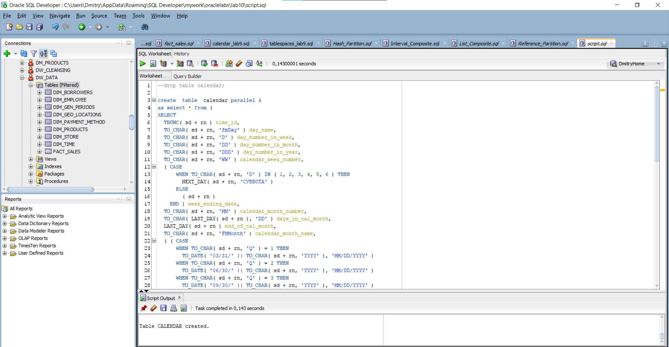

Picture - Creating calendar table

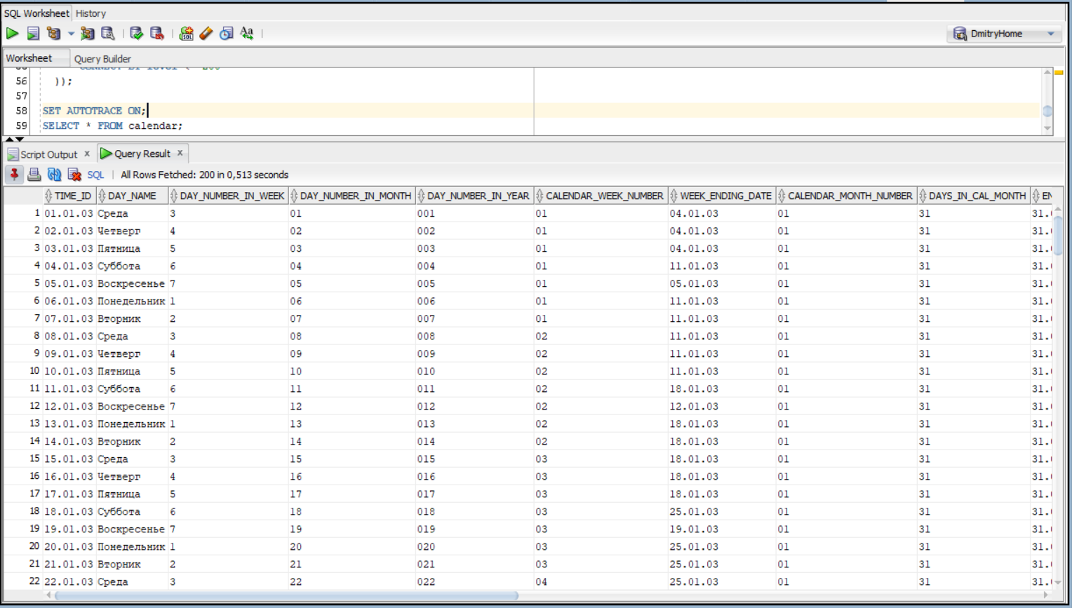

Picture - Select from calendar

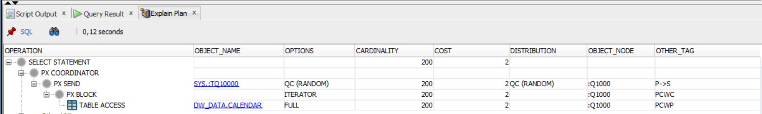

Picture 3 - Explain plan of select

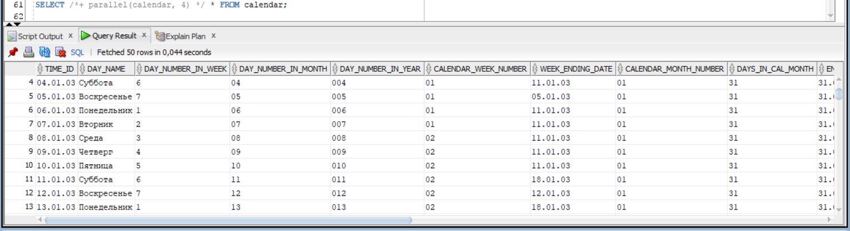

Picture 4 - Select with hint of parallel execution

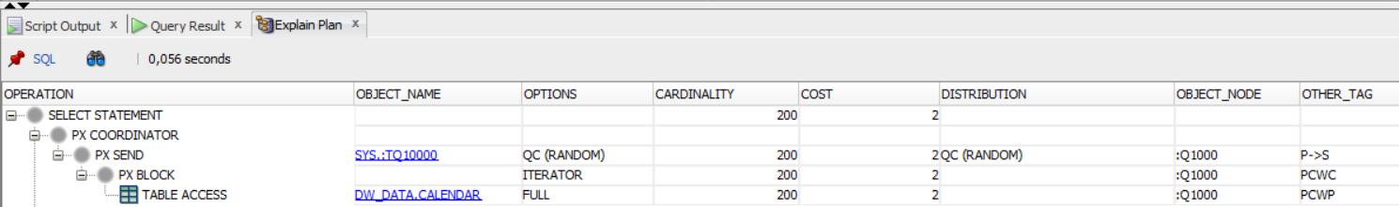

Picture 5 - Explain plan of select with hint of parallel execution

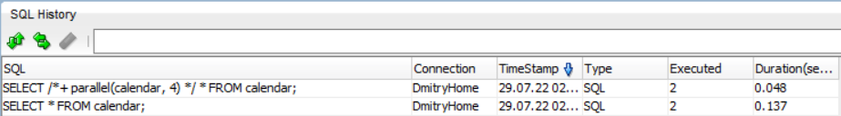

Picture 6 - Comparing selects

If we compare two variants of selects, we can see the principal difference.

## 2.2. Task 02: CREATE Example of Parallel DML

**The Main Task** is to creating example of Parallel DML

**Task Results:**

Create document that will store all screenshot about Parallel DML

* Scipts
* Execution Plan
* Summarize table – Compare time of the same operations

**Let us now delete data w\o parallelization:**

**P.S. I added 1000000 rows to better see differences**

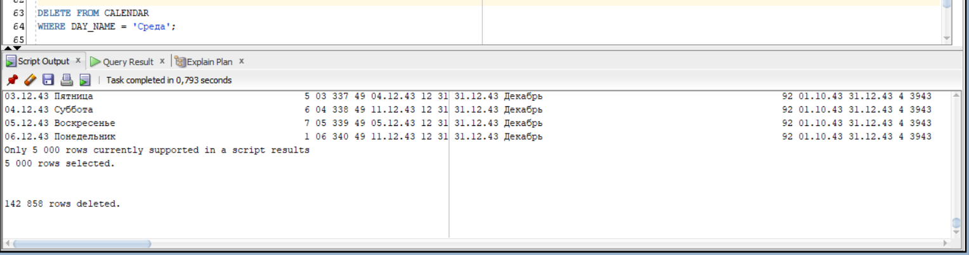

Picture - Deleting Data

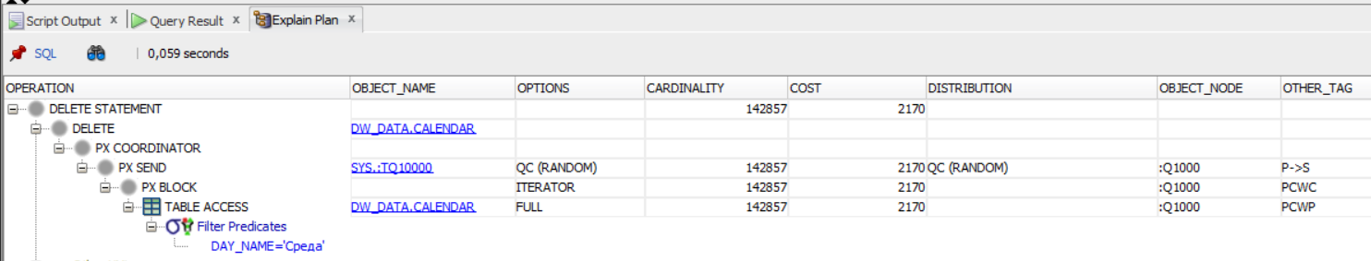

Picture - Explain plan

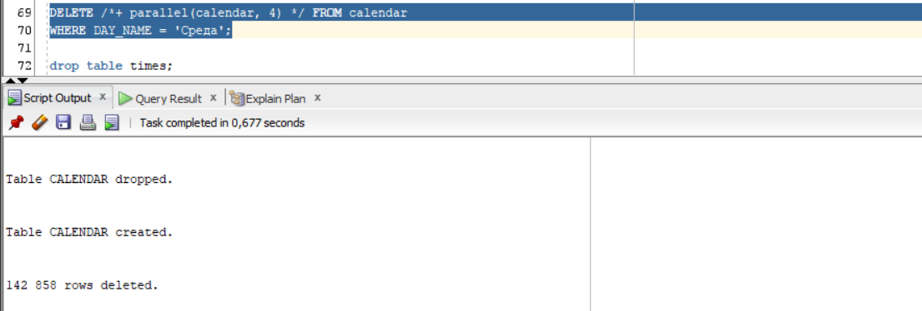

Picture - Deleting with parallelization

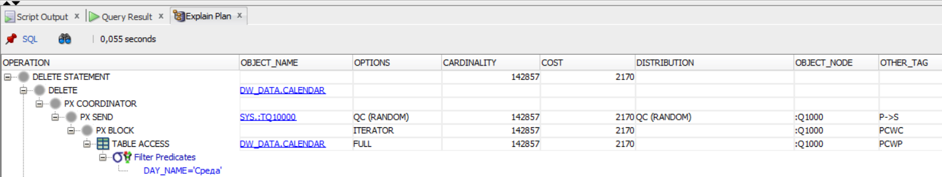

Picture - Explain plan

|  |  |  |
| --- | --- | --- |
|  | Simple DELETE | DELETE with PARALLEL execution |
| Duration | 0.219 | 0.268 |

## 2.3. Task 03: CREATE Example of Parallel DDL

**The Main Task** is to creating example of Parallel DDL

**Task Results:**

Create document that will store all screenshot about Parallel DDL

* Scipts
* Execution Plan
* Summarize table – Compare time of the same operations

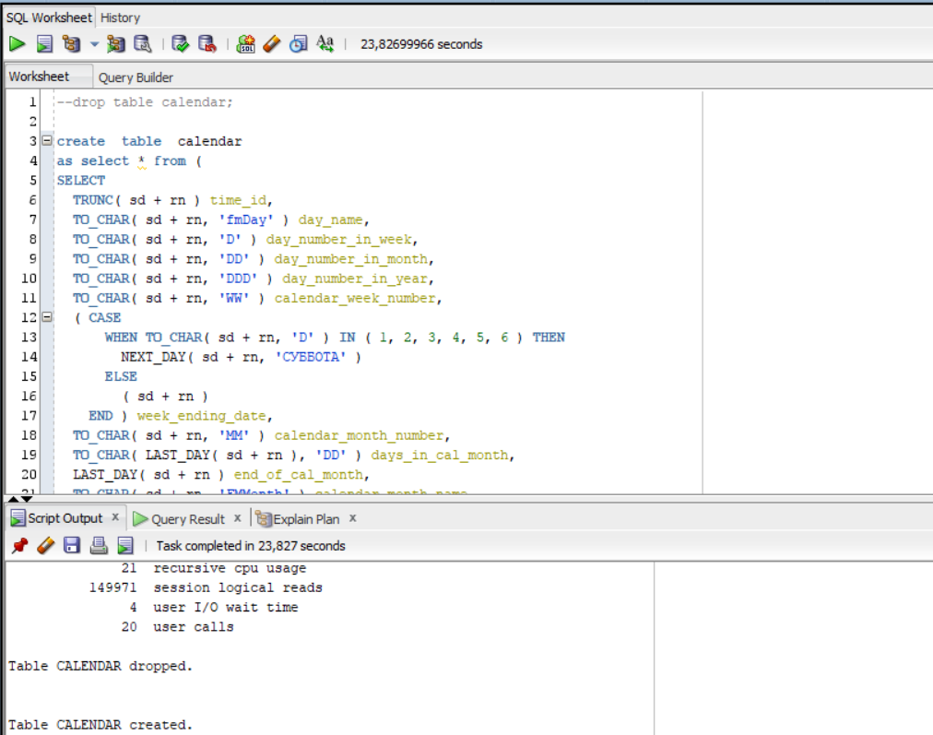

Picture 11 - Creating table w\o parallelization

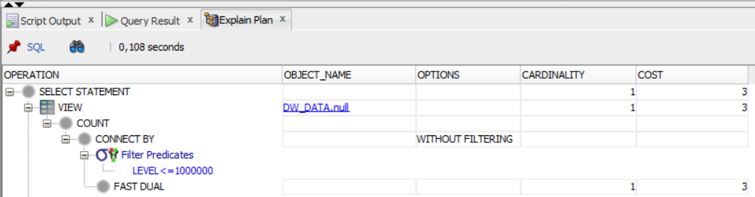

Picture - Explain plan

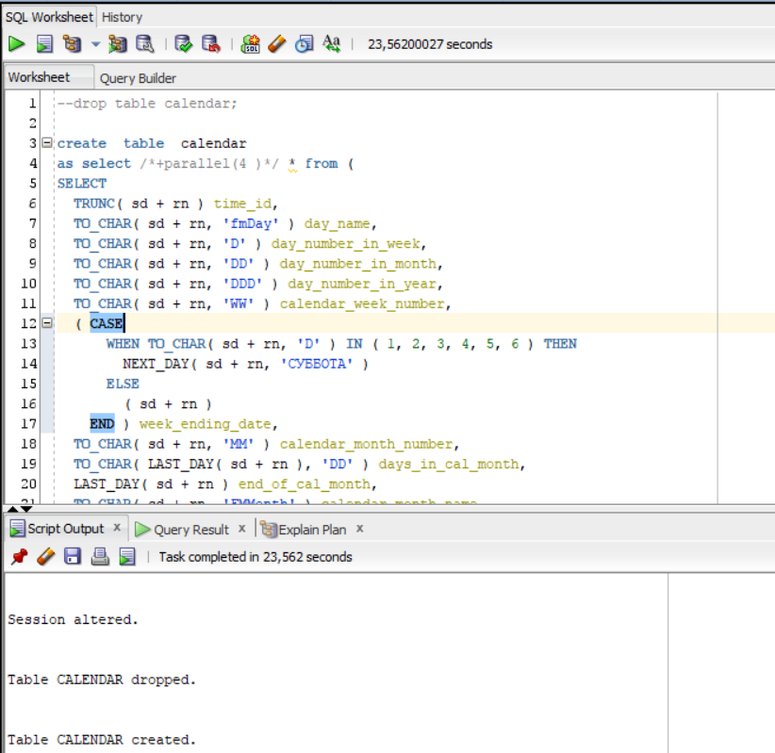

Picture 13 - Creating table with hint of parallelization

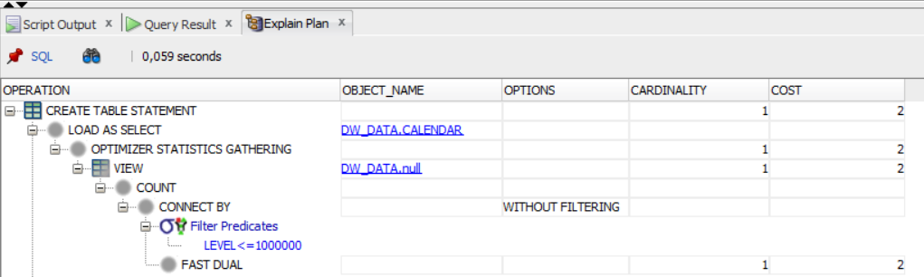

Picture - Explain plan

|  |  |  |
| --- | --- | --- |
|  | Simple CREATE | CREATE with PARALLEL execution |
| Duration | 23.826 | 23.562 |

**Laboratory work summary:**

Despite we use 100000 rows this amount is not that big to show such principal difference, so, the parallelization does not improve the results. To benefit from parallel query execution, we need to work with tremendous amount of data.

All diagrams and scripts are stored in GitHub (link in README file in Labs folder)